

***Artificial Intelligence (Lab)***

***Assignment - 5***

**Name:**

Ali Maqsood.

**Roll no:**

SU92-BSAIM-F23-050.

**Department:**

Software Engineering Department.

**Program:**

Artificial Intelligence.

**Section:**

BSAI-3A

**Question # 1:**

DFS with Stack & Node

**Explanation:**

In the given code we first introduce a graph with multiple nodes that are connected with each other. After that we are making a function bn the name of “dfs” after that we are using a stack to go through the complete graph. First we pop the first element from the stack and make it a node after that we check if the node is already visited if no that we add the node as visited and make all the elements of that node in our stack as we are going to be visiting them next.

**Code:**

graph={

    "A":["B","C"],

    "B":["D","E"],

    "C":["F"],

    "D":[],

    "E":["F"],

    "F":[]

}

def dfs(graph,start):

    stack=[start]

    visited=[]

    while stack:

        node=stack.pop()

        if node not in visited:

            visited.append(node)

            print(node)

            for i in graph[node]:

                stack.append(i)

dfs(graph,"A")

**Output:**

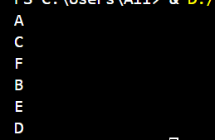

**Question # 2:**

Research about "Inorder, Preorder, Postorder" and implement in DFS

**Answer:**

These are the type of traversals that we can use for dfs(Depth First Search) for binary trees. They define the orders in which the nodes of the binary trees are visited.

**Example Tree:**

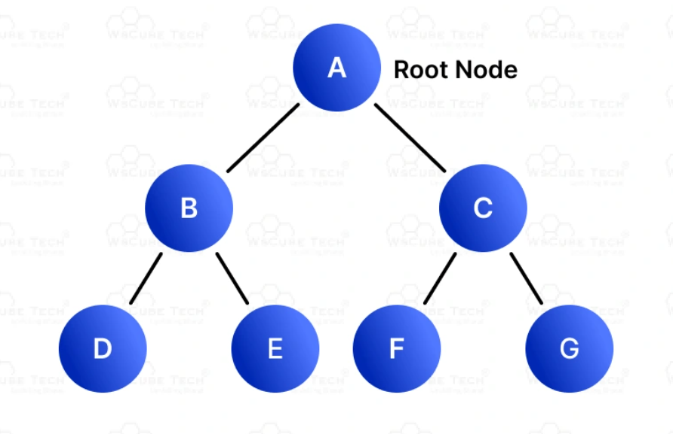

Following is my research on all of the three given terms:

**In-order**:

In this type we start from the Root node first (The top of the tree). After that we traverse towards the left nodes to the bottom and then go visited the other nodes by backtracking. If we focus on the give example binary tree it will give us the following answer:

[A, B, D, E, C, F]

**Pre-order**:

In this type we start from the Left most bottom node first. After that we go its neighbour nodes and, in this way, we go the top node that we reach and traverse the right side of the binary tree. If we focus on the give example binary tree it will give us the following answer:

[D, B, E, A, C, F]

**Post-order**:

In this type we start from the lest sub-tree we visit it completely than we go towards the right sub-tree we traverse it to the end and then we finally reach the top node also known as root node. If we focus on the give example binary tree it will give us the following answer:

[D, E, B, F, C, A]